**Assignment -8**

Question :

Explain the below aws architecture diagram in detail, also deploy the same aws

architecture.

● For this assignment you need to take a look and study the documentation for SAM CLI,

you need to deploy a Hello, World application on aws lambda.

● Make sure when you test the lambda url it will respond as Hello, World.


      A diagram of a Lambda function that's invoked when you send a GET request to the API Gateway
        endpoint.
    

**Ans**:

The above AWS architecture diagram has Two AWS services 1. API Gateway 2. AWS Lambda

HelloWorldAPI is used to make Get request to the Lambda function HelloWorldFunction.

And Lambda function will return respond as Hello, World.

Task 1: Deploy Hello World application on AWS Lambda using SAM CLI

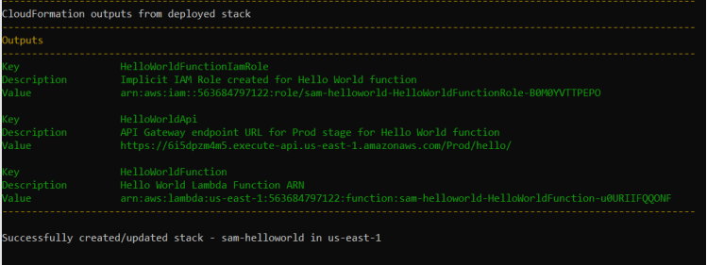

Task 2: Tested the Lambda URL, it responded as Hello, World.

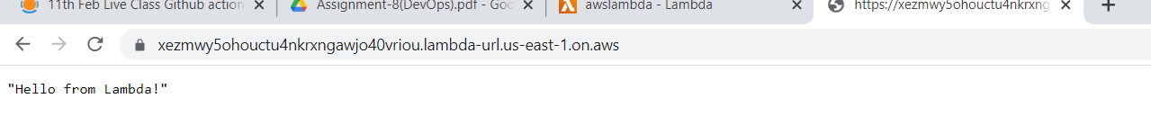

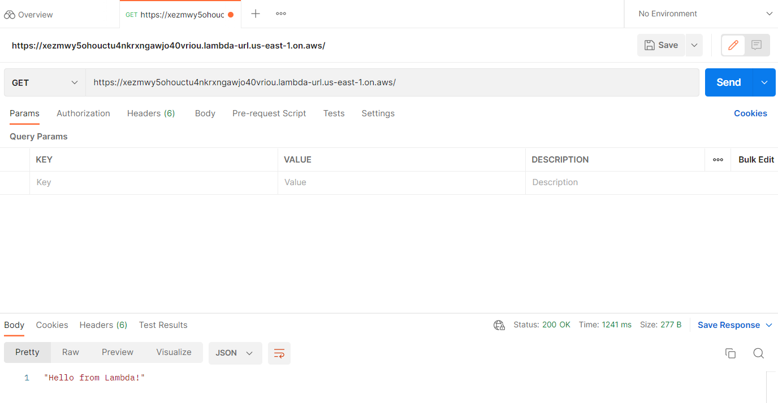

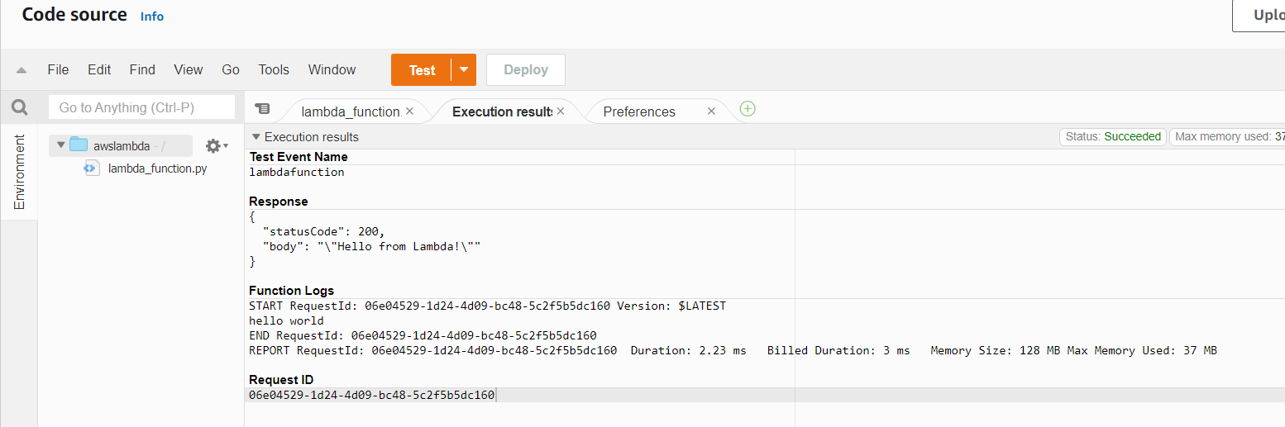

It Responded Hello World**.**